|  |  |  |  |  |
| --- | --- | --- | --- | --- |
|  | | | | |
|  |  |  | |  |
| CAOTIC ABAP Software Development kit (CASDK)  v.1.0.0 - Release Notes & Installation Guide | | |
|  | |  |

release overview 1

1. SUMMARY 1

2. FEATURES INCLUDED 1

Installation instructions 2

1. CREATE WORKBENCH REQUEST 2

2. CREATE CASDK PACKAGE 2

3. CREATE CASDK DEFINITION INCLUDE 2

4. CREATE CASDK IMPLEMENTATION INCLUDE 2

5. CREATE CASDK SYNTAX CHECK PROGRAM 2

6. RELEASE WORKBENCH REQUEST 2

HOW TO USE THE SDK 3

1. INCLUDE FOR PROGRAMS/REPORTS 3

2. INCLUDE FOR FUNCTIONAL MODULES 3

3. INCLUDE FOR GLOBAL CLASSES 3

# release overview

## SUMMARY

## FEATURES INCLUDED

# Installation instructions

## VALIDATE SYSTEM VERSION

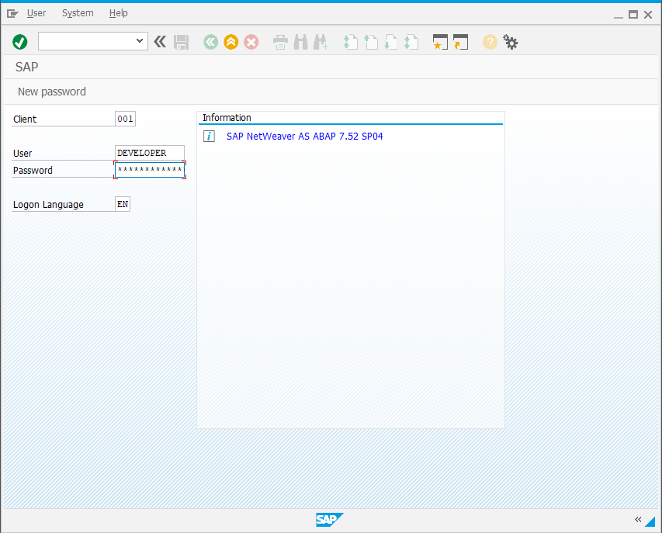

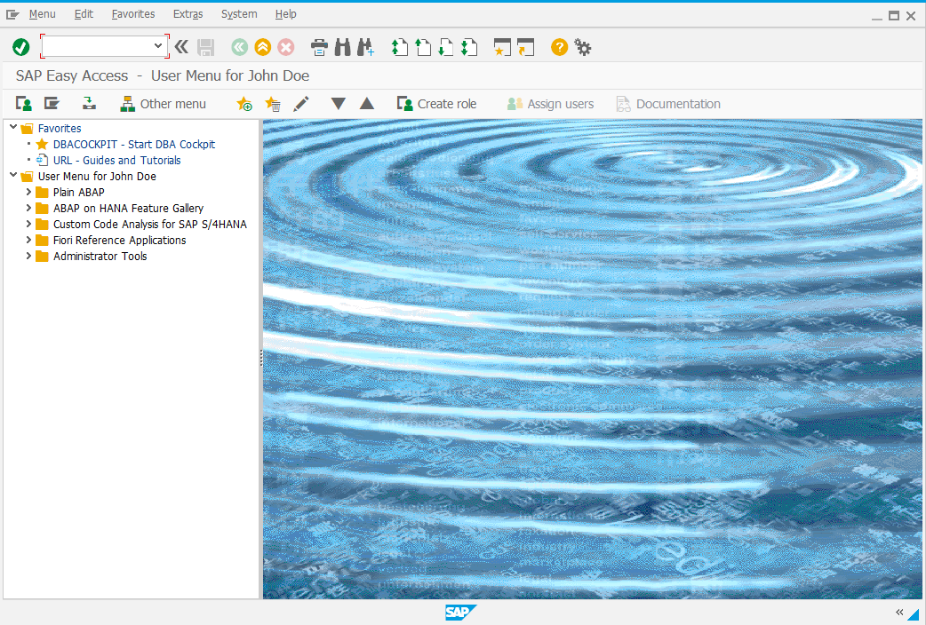

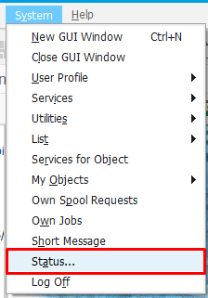

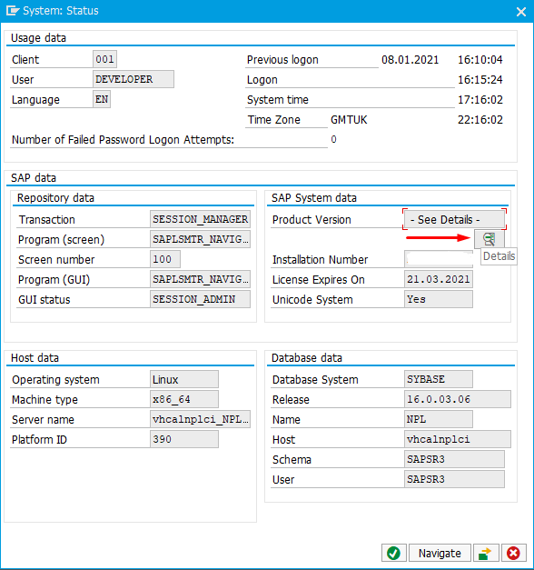

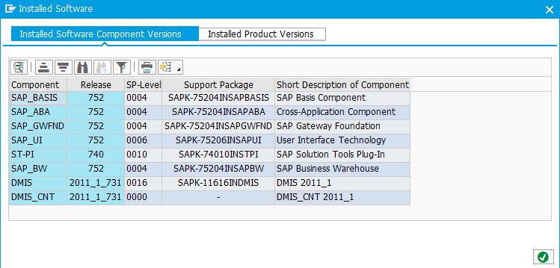

## CREATE WORKBENCH REQUEST

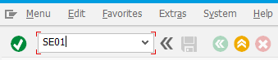

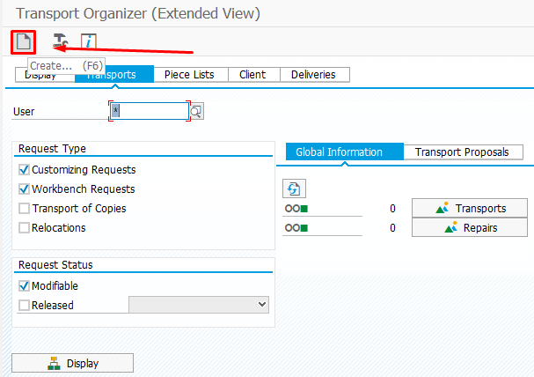

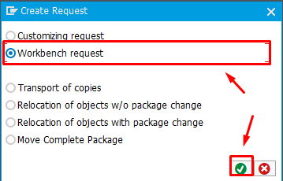

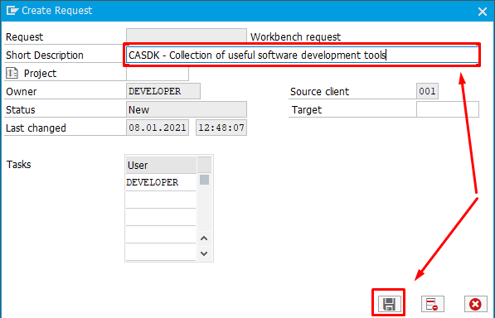

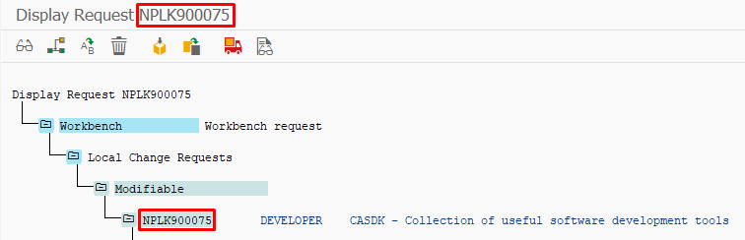

## CREATE CASDK PACKAGE

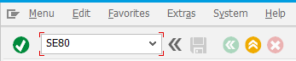

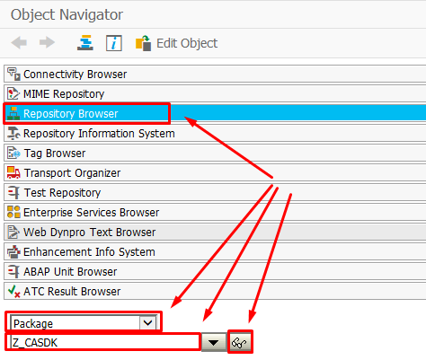

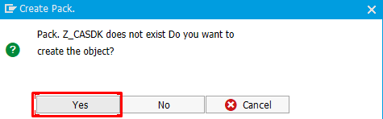

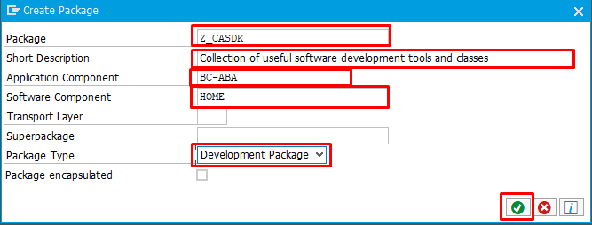

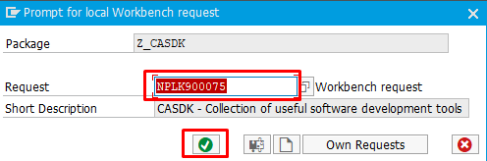

## CREATE CASDK DEFINITION INCLUDE





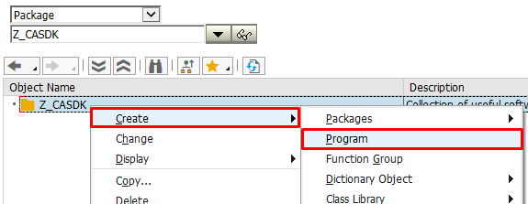

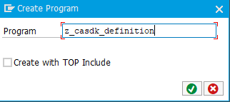

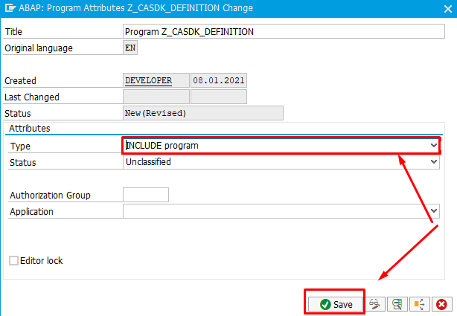

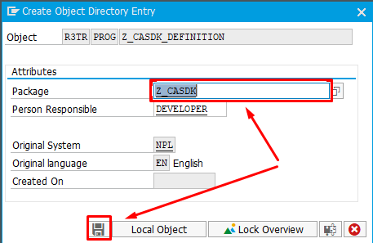



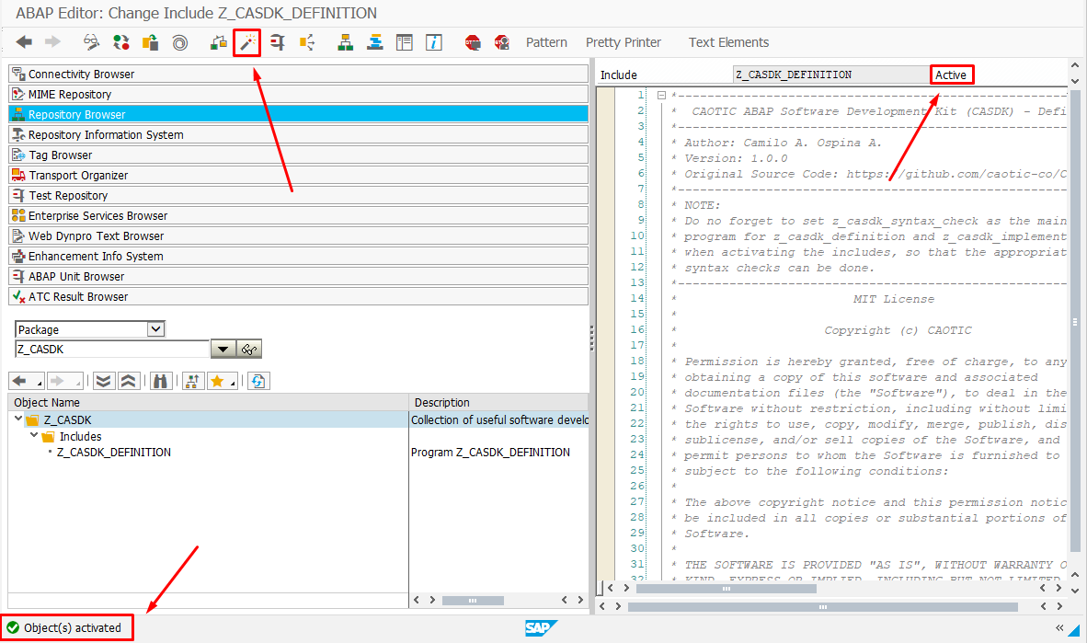

## CREATE CASDK IMPLEMENTATION INCLUDE







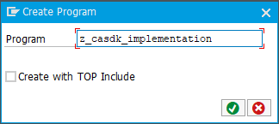

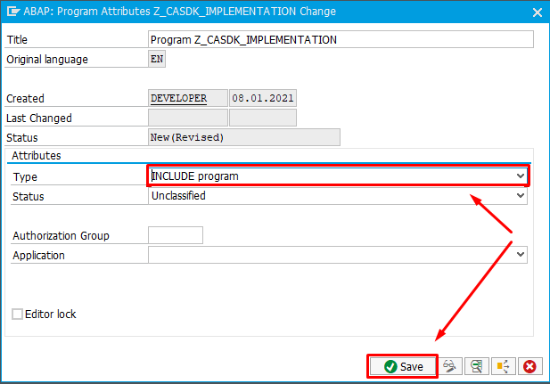

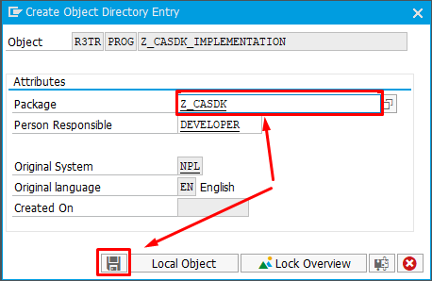



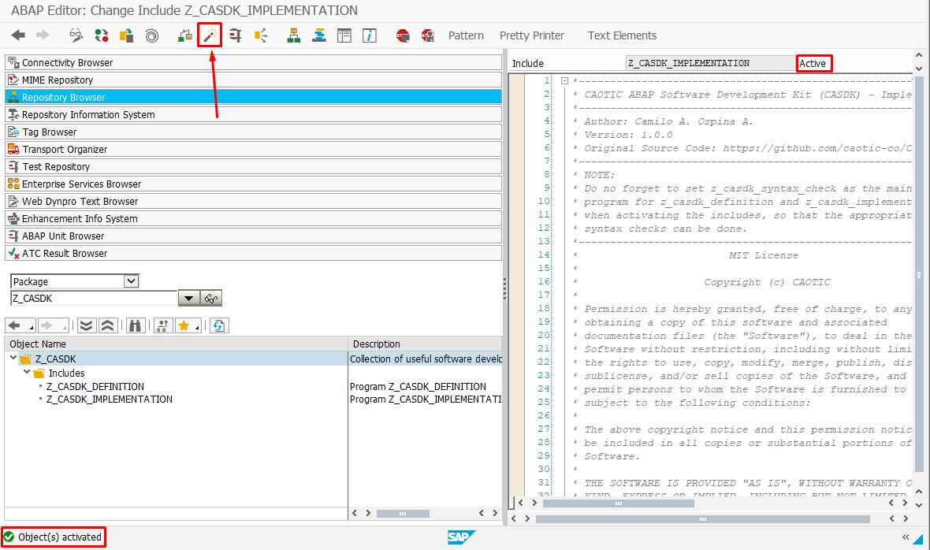

## CREATE CASDK SYNTAX CHECK PROGRAM







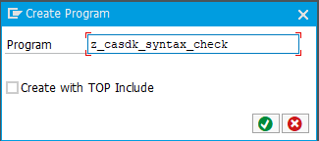

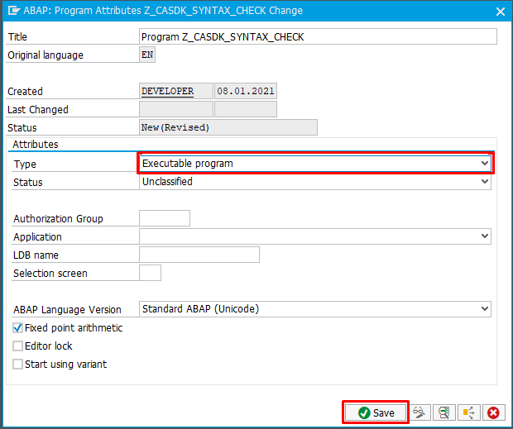

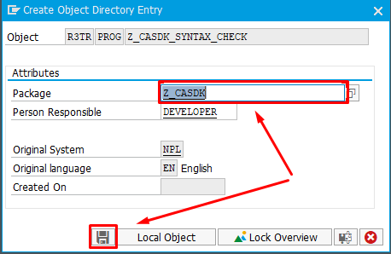



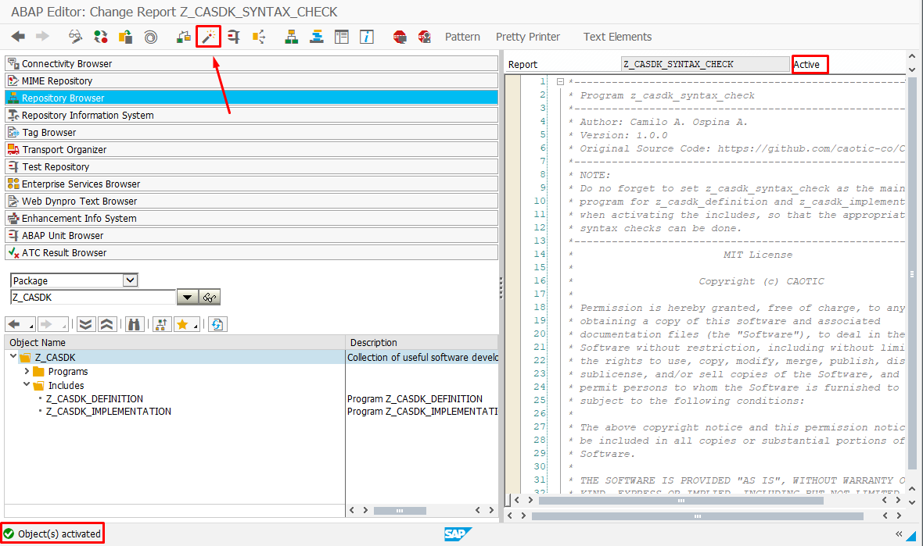

## RELEASE WORKBENCH REQUEST



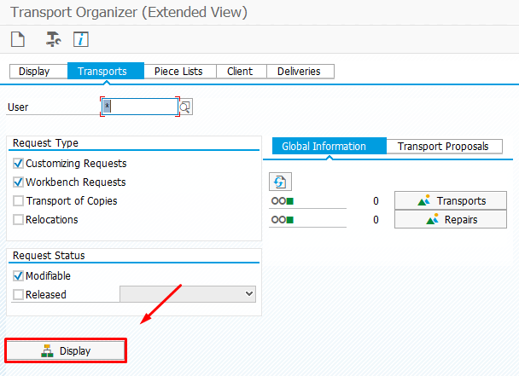

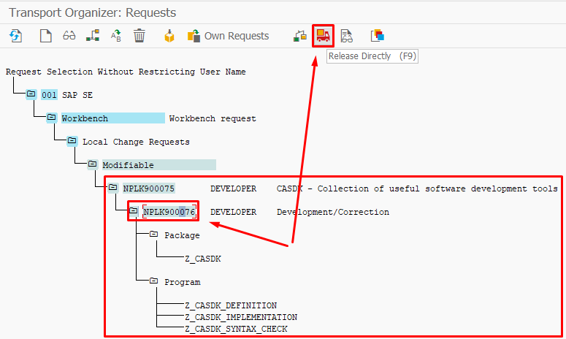

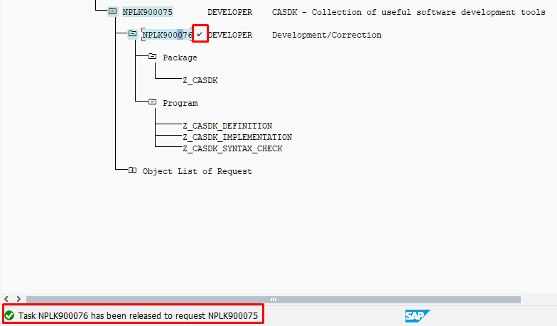

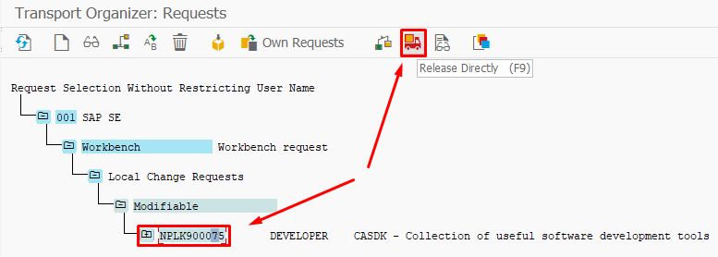

# HOW TO USE THE SDK

## INCLUDE FOR PROGRAMS/REPORTS

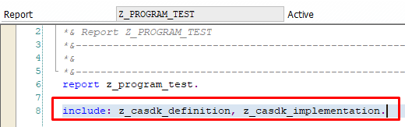

## INCLUDE FOR FUNCTIONAL MODULES

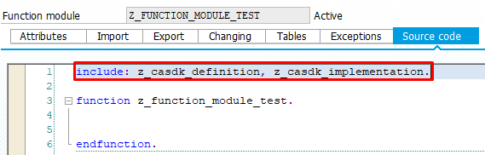

## INCLUDE FOR GLOBAL CLASSES

